




Prepared By:
Joshua Alford
Analytical Laboratory Manager
Prepared For:
Canevolve
Analytical Data Summary
Summary of results report for the analysis and quantitation of Cannabidiol in CBD E-liquid by HPLC/UV
UK Flavour
Unit B3
Bridlington Business Park
Bessingby Industrial Estate
Bridlington
YO16 4SJ


Summary Report – Canna Drip - Shortberry Strawcake 20mg/mL CBD E-liquid

Summary
A summary of results for the analysis of Canna Drip - Shortberry Strawcake 20mg/mL CBD infused E-liquid is included in Table 1 below. The results confirm that the Cannabidiol content of Canna Drip - Shortberry Strawcake 20mg/mL CBD infused E-liquid is 21.50mg/mL.

Table 1: Cannabidiol Results
Test | Specification mg/mL | Result mg/mL
CBD | 18.0-22.0 | 21.50

Quantification
The quantification of CBD was performed using in house HPLC method LC02. Experimental Chromatography is shown in Figure 1

Figure 1: Experimental Chromatography
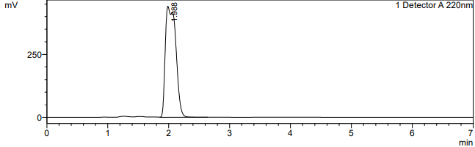 | 