
EUPHORIA TRADE s.r.o.
Klimentska 1216/46, 110 00 Prague, Czech Republic. www.cannabisfood.cz / info@euphoria.trade / +420 266 793 203

EUPHORIA CBD Oil 20%

PRODUCT SPECIFICATION

Ingredients: Hemp extract containing CBD, hemp oil.
Storage Conditions: in a dry and cool place.
Content: 10ml / 2000 mg CBD. Produced in the Netherlands for EUPHORIA TRADE s.r.o.

ANALYSIS REPORT
Procedure:
Identification and quantification of cannabinoids has been performed via HPLC analysis according to the
producer’s analytical methods.
Samples are analysed in duplicate.
The data is reported when the duplicate analysis showed that:
- the 6 standards used in sequence have RSD% < 2%
- the main component has RSD% < 5%
- other components to quantified have RSD% < 10%

Product information:
Sample: 20% CBD Oil. | Analysis date: 20.06.2018 | Batch nr.: 18M0013D3 Expiration date: June 2019
Results:
Cannabinoids |  | Results
CBD |  | 20,47 %
Δ⁹ - THC  Δ⁸ - THC |  | 0,19 %  n.d.
THCA |  | n.d.
CBDA |  | 0,06 %
CBG |  | n.d.
CBGA |  | <0,01 %
CBN |  | n.d.
CBC |  | 0,11 %
THCV |  | n.d.
n.d.: not detected.

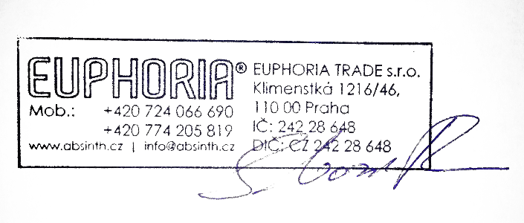
Approved by: Sardor Varisov In Prague, 27.06.2018

