RECIPE | SUGAR FREE CHEWING GUM WITH SWEETENERS. WITH CBD
Global appearance of product | Chewing gum with white coating, rectangular shape, soft in the core
Flavour | Hemp flavour
Tipology of product | Sugar FREE chewing gum with sweeteners
Shape | Rectagle shape, Weight 1.44 g +/- 0.05 g
INGREDIENTS | Sweeteners: sorbitol, isomalt, maltitol syrup, acesulfame k, sucralose; gum base (contains SOY LECITHIN), flavours; thickening agent: arabic gum; humectant: glycerol; colour E171; CBD; glazing agent: carnauba wax; antioxydant: E321.
% INGREDIENTS | 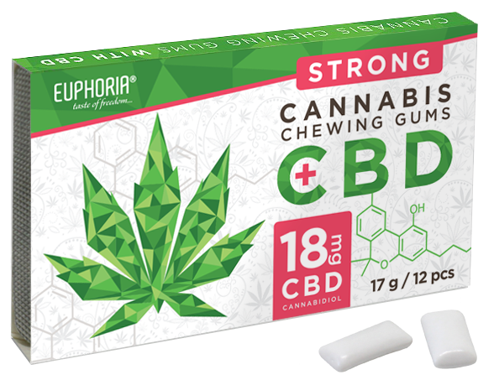
  Name | %
  Sorbitol | 40,95
  Isomalt | 28,00
  Gum base | 21,00
  Maltitol syrup | 4,90
  Flavours | 3,31
  Arabic gum | 0,7
  Glycerol | 0,7
  Acesulfame k | 0,11
  Sucralose | 0,11
  E171 | 0,10
  CBD | 0,07
  Carnauba wax | 0,05
  Antioxidant | 0,01
  Total | 100
Nutrition informations
  PER 100g |  | Per 1 chewing gum 1,44 g
  ENERGY | 744,1 KJ (178,6 kcal) | 10,71 KJ (2.57 Kcal)
  FA | 0 g | 0 g
  Of which saturated fats acids | 0 g | 0 g
  CARBOIDRATES | 73,8 g | 1 g
  Of wich polyols | 73,8 g | 1 g
  Of wich sugar | 0 g | 0 g
  FIBRE | 0.7 g | 0.01 g
  PROTEIN | 0 g | 0 g
  SALT | 0 g | 0 g
  CBD | 105,88 mg | 1,5 mg
Packaging | 1 pack 17 g of gums with 12 gums
Transport and storage conditions | Store cool and dry. Keep away from the humidity and heatfonts. (12-30°C- 50/60% r.h.)
Shelf life | 2 years under storage conditions described above
GMO | GMO free
Allergens | Soy
Consumers | Celiac disease  Yes | Seniors  Yes |  | Children  No |  | Vegans  Yes |  | Diabetics  Yes
Warnings | Excessive consumption may produce laxative effect.
Microbiological features (ufc/g) | TMC  <3000 |  | Total Coliforms  Absent |  | Salmonella  Absent |  | Staphylococcus aureus  Absent |  | Moulds and yeasts  <100

