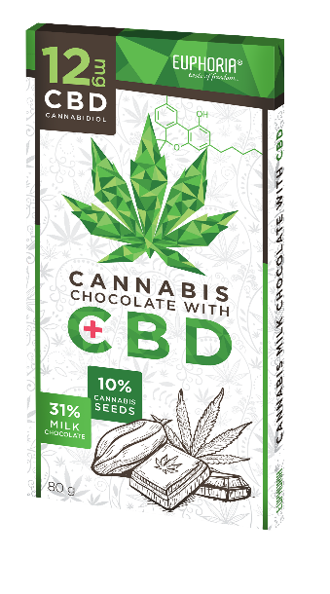

NAME

Milk chocolate with hemp seed & 12 mg CBD

Milk chocolate with the addition of 10% cannabis seeds & 12 mg CBD

Description: Rectangular chocolate rectangular cocoa bean table wrapped in aluminum foil and paper box

Country of origin: Czech Republic

MICROBIOLOGICAL PARAMETERS
Rules of Good Manufacturing and Hygiene Practice - Microbiological Criteria for Food and internal regulations and standards:
Total number of microorganisms / g ČSN ISO 4833 | < 5.10³
Mold / g ČSN ISO 7954 | < 10¹
Salmonella spp./25g ČSN EN ISO 6579 | negat.
Enterobakterie/g ČSN ISO 7402/1995 | Max 5.10²

PHYSICAL-CHEMICAL PARAMETERS
According to internal standards and regulations:
Contents total. cocoa solids in milk chocolate | min. 31 %
Content of milk solids in milk chocolate | min. 18%
Content of hemp seed in the product | max. 10%
THC content in hemp seed | max. 0,02 %

ORGANOLEPTIC PROPERTIES
According to internal standards and regulations:
Appearance | at a normal temperature of 20 ° C, a hard homogeneous mass, with a mixture of hemp. seeds
Color | light brown with white hemp seeds
Smell | chocolate, no foreign smell
Taste | milk chocolate, flavored with cannabis oil seeds, without foreign flavors

COMPOSITION
sugar, cocoa butter, whole milk powder, cocoa mass, peeled hemp seed (10%), emulsifiers (soy lecithin and polyglycerol-polyricin oleate), hemp seed (10%), vanilla extract BOURBON MADAGASCAR, cannabis extract containing CBD.

The energy value is the value calculated according to the nutritional values of the raw materials used, it is not determined by the laboratory
energy value in 100 g of product  fats  of which saturated fatty acids  carbohydrates  of which sugars  fiber  proteins  salt | 2317 kJ - 556 kcal  35 g  19 g  51 g  50 g  1,8 g  8,0 g  0,28 g

HYGIENIC PROPERTIES
They are in line with the prospects. No. 305/2004 Coll. as amended, and Commission Regulation (EC) No 1881/2006, as amended
 | PM (mg/kg)
Arsen | 0,5
Lead | 1,0
Mercury | 0,01
The product complies with the requirements of EU Regulations 1829/03 and 1830/03, does not contain g.m.o.
The product complies with the quality and health requirements laid down in the Implementing Regulations to the Food Act No. 110/97 Coll.
MAY CONTAIN STAINS OF SOYA AND DRIED SKAFFLE PLANTS

