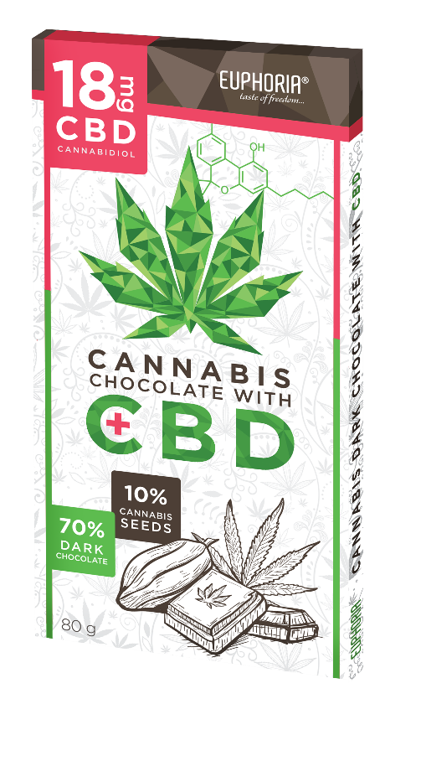

NAME

Dark chocolate 70% with hemp seed & 18 mg CBD

Dark chocolate with the addition of 10% cannabis seeds & 18 mg CBD

Description: Rectangular chocolate rectangular cocoa bean table wrapped in aluminum foil and paper box

Country of origin: Czech Republic

MICROBIOLOGICAL PARAMETERS
Rules of Good Manufacturing and Hygiene Practice - Microbiological Criteria for Food and internal regulations and standards:
Total number of microorganisms / g ČSN ISO 4833 | < 5.10³
Mold / g ČSN ISO 7954 | < 10¹
Salmonella spp./25g ČSN EN ISO 6579 | negat.
Enterobakterie/g ČSN ISO 7402/1995 | Max 5.10²

PHYSICAL-CHEMICAL PARAMETERS
According to internal standards and regulations:
Contents total. cocoa solids in dark chocolate | min.70 %
Content of hemp seed in the product | Max. 10 %
THC content in hemp seed | Max. 0,02 %

COMPOSITION
cocoa mass, sugar, cocoa powder with reduced fat peeled hemp seed (10%), cocoa butter, emulsifier (soy lecithin and polyglycerol oleate polyricin) MADAGASCAR BOURBON vanilla extract, , cannabis extract containing CBD.

The energy value is the value calculated according to the nutritional values of the raw materials used, it is not determined by the laboratory
energy value in 100 g of product  fats  of which saturated fatty acids  carbohydrates  of which sugars  fiber  proteins  salt | 2287 kJ - 552 kcal  41 g  23 g  28 g  24g  11 g  11g  0,15 g

ORGANOLEPTIC PROPERTIES
According to internal standards and regulations:
Appearance | at a normal temperature of 20 ° C, a hard homogeneous mass, with a mixture of hemp. seeds
Color | dark brown with white cannabis seeds
Smell | chocolate, no foreign smell
Taste | bitterly chocolate, flavored with cannabis oil seeds, without foreign flavors

HYGIENIC PROPERTIES
They are in line with the prospects. No. 305/2004 Coll. as amended, and Commission Regulation (EC) No 1881/2006, as amended
 | PM (mg/kg)
Arsen | 0,5
Lead | 1,0
Mercury | 0,01
The product complies with the requirements of EU Regulations 1829/03 and 1830/03, does not contain g.m.o.
The product complies with the quality and health requirements laid down in the Implementing Regulations to the Food Act No. 110/97 Coll.
MAY CONTAIN STAINS OF SOYA AND DRIED SKAFFLE PLANTS

