Product name: | Oatmeal biscuits, with hemp and chocolate
Company: | EUPHORIA TRADE s.r.o.  Klimentská 46, 110 02 Prague 1, Czech Republic
Certified Management System | IFS
Country of origin | Czech Republic
Classification according to Decree 182/2012 Coll. as amended
Type | Long durability pastry
Group | Biscuits
Product Ingredients | Wheat flour, vegetable fat (palm oil and palm fat, water, salt,  emulsifier: sunflower lecithin, mono and diglycerides of fatty  acids, acid: citric acid, coloring: carotene, natural flavoring),  sugar, barley flour, 2.5% chocolate (sugar, cocoa mass, cocoa  butter, dextrose, emulsifier: soy lecithin, flavor), oatmeal 1.9%,  glucose syrup with a high maltose 1.2% hemp seed, whey powder,  malt extract barley, hemp moldings 1%, bulking agent: sodium  bicarbonate, ammonium bicarbonate, egg, emulsifier: sunflower lecithin.
Product durability | 12 months from date of production
Storage conditions | Dry to 30 ° C, without direct sunlight
The product complies with the following legislative requirements: Act No. 110/1997 Coll., Regulation (EU) No 1169/2011 of the European Parliament and of the Council as amended
PACKAGING
Consumer packaging | PP wrapping, PAP box
Primary Health Insurance | Complies with the requirements of Commission Regulation (EU) No 10/2011 of 14 January 2011 on plastic materials and articles intended to come into contact with food (as amended)
Consumable packaging weight | 100 g (minimum 91 g)
Group packaging | three-ply cardboard
Distribution | In dry, clean, in the absence of direct sunlight, with compatible "material". Distribution temperature up to 30 C.
ORGANOLEPTIC PROPERTIES
Appearance, shape | Oval and square biscuits, top embossed; Square 30/30/7, oval 34/29/7, circle 33/7
Color | Golden with green pieces of hemp and chocolate pieces
Smell and taste | Typical, after used raw materials (cannabis, chocolate), sweet
PHYSICAL AND CHEMICAL PROPERTIES
Tag |  | Permitted range | Frequency of tracking | Method of determination
Humidity |  | Max. 7% | Each batch | Drying weight
Impurities, admixtures | Metal | 0% | Each product | metaldetector
 | Pests | 0% | Each batch | sensory
 | Mineral impurities | 0% | Each batch | sensory
 | Other impurities | Max. 0,1% | Each batch | sensory
NUTRITION VALUES (per 100 g of product)
An energy value | 1902 kJ
Fats | 22 g
Of this, saturated fatty acids | 3,6 g
Carbohydrates | 58,9 g
Of which sugars | 19,8 g
Protein | 8 g
Salt | 0,1 g
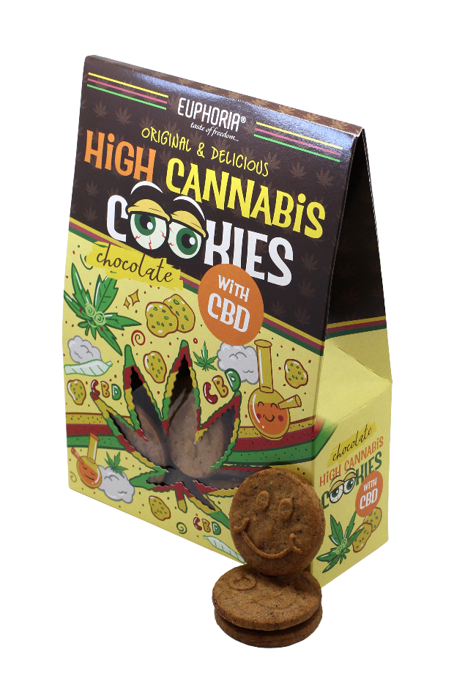

DECLARATION
ONIZING RADIATION | The product is treated with ionizing radiation |  | NO
GMO | The product contains GMO |  | NO
ALERGENS | Allergen in product (from recipe) | Allergen presence in the production hall
Cereals containing gluten | x | x
Crustaceans and products thereof
Eggs with products from them | x | x
Fish and related products
Peanuts |  | x
Dry nuts and products thereof
If so, which
Milk and products thereof | x | x
Soya beans and products thereof | x | x
Celery and products from it
Mustard and products thereof
Sesame seeds and products thereof |  | x
Sulfur dioxide and sulphites
Molluscs and products thereof
Lupine and products thereof

