Product Name: CBD Tea
General information
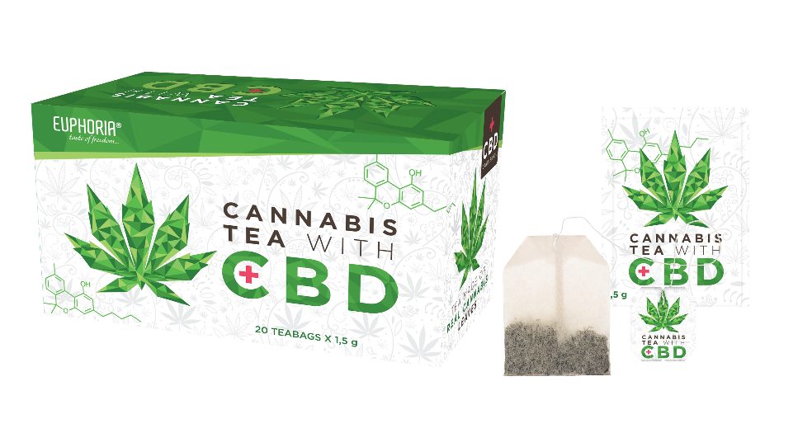
General characteristics / classification: herbal tea, diet supplement
Ingredients: chamomile 32%, lemon balm 30%, lemon grass 15%, hemp seeds 10%, sallow-thorn berries 5%, orange oil flavour 5%, hemp leaves 3%
Packing: box, 20 sachets 1.5 g
Weight: 30 g
Shelf-life: 2 years

Storage conditions: 20-25 ° C
Preparation and dosing: label

Senzorické vlastnosti
Parameter | description
Appearance | Herbal tea, chamomile
Taste  Scent  Color of the brine | Typical herb without any smell  The smell of the chamomile and hemp  green-yellow

Physical-chemical properties
Parameter | limit
humidity | Up to 12%
foreign admixtures | 2%
Total ash | 10%

Parameter | Limit
Heavy metals | Pb- less than 5.0 mg / kg  Cd less than 1.0mg / kg  Hg-less than 0.1 mg / kg
Pesticides | in line with EU legislation
Microbiological properties
Parameter | Permissible value
CMP | 10⁷ CFU / g
Yeast and mold | 10⁵ CFU / g
E.coli | 10³ CFU / g
Salmonela | Negative / 10g

The product complies with the requirements of current EU legislation.
Allergen occurrence: 0

